|  |
| --- |
| ***Almond Milk Chia Pudding*** |

|  |  |
| --- | --- |
| ***Full Batch Recipe*** | |
| Chia seeds | 200g / 973 Cal |
| Unsweetened Almond Milk | 600g / 120 Cal |
| Low fat yogurt | 720g / 360 cal |
| Banana ripe yellow color not green | 300g / 300 cal |
| Honey | 80g / 243 Cal |
| Maple Syrup | 80g / 208 Cal |
| Vanilla | 10g / 32 Cal |
| Total | 1990g / 2236 Cal  1.12 Cal/g |

|  |  |  |  |
| --- | --- | --- | --- |
| **Portions** | **1P** | **2P** | **3P** |
| Chia Pudding mix | 150g / 168 Cal | 200g / 224 Cal | 250g / 280 Cal |
| Cranberry | 10 g / 30 Cal | 10 g / 30 Cal | 10 g / 30 Cal |
| ***Total*** | ***198 Cal*** | ***254 Cal*** | ***310 Cal*** |

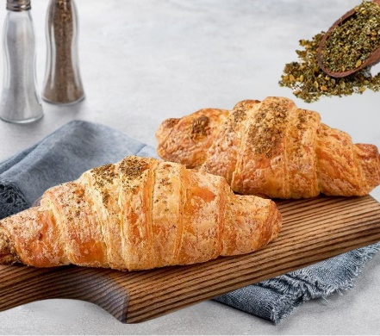

***THYME CROISSANT (from Supplier)***

|  |  |  |  |
| --- | --- | --- | --- |
| Thyme Croissant | 1p | 2p | 3p |
| Weight | 60g | 80g | 100g |
| Calories | 228 Cal | 303 Cal | 380 Cal |

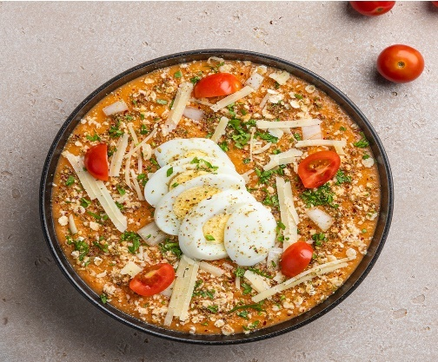

***Savory Oatmeal with Boiled Eggs and Parmesan***

|  |  |  |
| --- | --- | --- |
| ***Savory Oats*** | | |
| **Item Name** | **Quantity (g)** | **Calories** |
| White Onion | 150 g | 60 Cal |
| Sweet Potato | 450 g | 390 Cal |
| Oats | 90 g | 350 Cal |
| Cherry Tomatoes | 150 g | 25 Cal |
| Fresh Parsley | 30 g | 10 Cal |
| Zaatar | 5 g | 0 Cal |
| Olive Oil | 30 g | 270 Cal |
| Salt | to taste | 0 Cal |
| Pepper | to taste | 0 Cal |
| ***Total*** | 905 g before cook | 1105 Cal |
| 769 g after cook |
| ***1.44 Cal/g*** | |

|  |  |  |  |
| --- | --- | --- | --- |
| **Item Name** | **1P** | **2P** | **3P** |
| Savory Oats | 100 g / 140 Cal. | 120 g / 168 Cal. | 150 g / 210Cal. |
| Boiled Egg | 1 pcs / 75 Cal. | 2 pcs / 150 Cal. | 2 pcs / 150 Cal. |
| Feta Cheese Crumble | Garnish | Garnish | Garnish |
| ***Total*** | ***140 g / 215 Cal.*** | ***200 g / 318 Cal.*** | ***230 g / 360 Cal.*** |

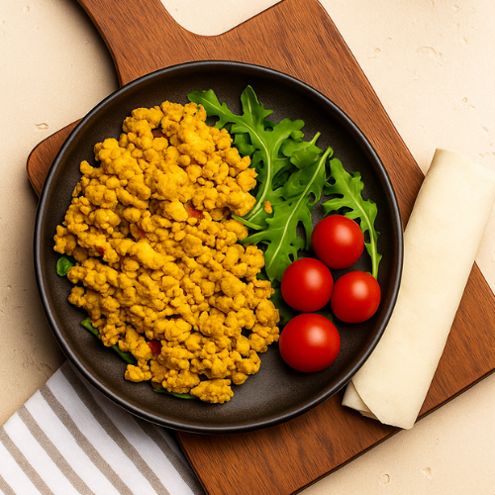

***Egg Shakshuka Recipe:***

|  |  |  |
| --- | --- | --- |
| **Item Name** | **Quantity** | **Calorie** |
| ***Sauce:*** | | |
| Onion Cut Minced | 200 g | 80 |
| Minced Garlic | 20 g | 30 |
| Fresh Green Chili | 10 g | 10 |
| Fresh Tomato | 500 g | 85 |
| Paprika | 5 g | 15 |
| Cumin | 5 g | 15 |
| Salt | 7 g | 0 |
| White Pepper | 1 g | 3 |
| Chili Flex | 2 g | 6 |
| Chopped Green Bell Pepper | 100 g | 20 |
| Tomato Paste | 100 g | 80 |
| Water | 300 ml | 0 |
| ***Total*** | ***1,250 g before cooking, 1 kg after cooking.*** | ***344 cal***  ***0.3 Cal/g*** |

|  |  |  |
| --- | --- | --- |
| **Item Name** | **Quantity** | **Calorie** |
| ***Egg:*** | | |
| Egg | 2 pcs (100 g) | 150 Cal |
| Sauce | 70 g | 23 Cal |
| ***Total*** | ***170g*** | ***173 Cal***  ***1 Cal/g*** |

|  |  |  |  |
| --- | --- | --- | --- |
| **Item Name** | **1P** | **2P** | **3P** |
| Egg | 75g 1.5 pcs before cooking | 100g 2 pcs before cooking / 150 cal | 150 g 3 pcs before cooking / 225 Cal |
| Sauce | 50g / 15 Cal | 70g / 23 Cal | 100 g / 30 Cal |
| Saj Bread | 30g / 80 | 45g / 110 Cal | 60g / 160 CCal |
| Rocca | 5g | 5g | 5 g |
| ***Total*** | ***207 Cal*** | ***283 Cal*** | ***415 Cal*** |

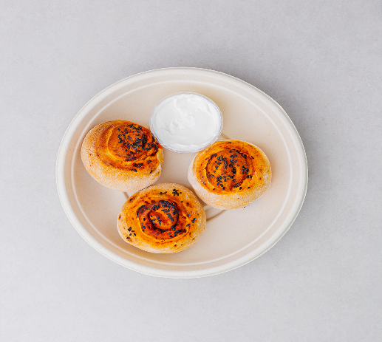

***Mouhamara Roll Recipe:***

|  |  |  |
| --- | --- | --- |
| **Item Name** | **Quantity** | **Calorie** |
| White Flour | 1 kg | 3,640 Cal. |
| Light Butter | 50 g | 258 Cal. |
| Maltitol | 40 g | 96 Cal. |
| Powder Milk | 50 g | 250 Cal. |
| Salt | 15 g | 0 Cal. |
| Yeast | 15 g | 15 Cal. |
| Water | 700 ml | 0 Cal. |
| Flaxseed | 2 g | 0 Cal. |
| ***Total*** | ***1,872 g*** | ***4259 Cal.***  ***2.3 Cal/g*** |
| **Item Name** | **Quantity** | **Calorie** |
| ***Veg. Mix.*** | | |
| Chopped Onion | 100 g | 40 Cal |
| Chopped Tomato | 200 g | 35 Cal |
| Black Olives | 35 g | 42 Cal |
| Fresh Thyme | 5 g | 5 Cal |
| Sweet Pepper Paste | 35 g | 17 Cal |
| Green Bell Pepper | 100 g | 25 Cal |
| Olive Oil | 35 g | 315 Cal |
| Tomato Paste | 10 g | 8 Cal |
| Salt | 5 g | 0 |
| ***Total*** | 525 g | 487 Cal  0.9 Cal/g |

|  |  |  |  |
| --- | --- | --- | --- |
| **Item Name** | **1p** | **2p** | **3p** |
| White Dough before cooking | 30 g / 69 Cal. | 30 g / 69 Cal. | 30 g / 69 Cal. |
| Veg. Mix | 25 g / 22 Cal. | 25 g / 22 Cal. | 25 g / 22 Cal. |
| Black Seeds (Garnish) | 1 g | 1 g | 1 g |
|  | Send 2 pieces | Send 3 pieces | Send 4 pieces |
| Labneh on the Side | 30g = 45 Cal | 30g = 45 Cal | 30g = 45 Cal |
| ***TOTAL*** | **227 Cal** | **318 Cal** | **409 Cal** |

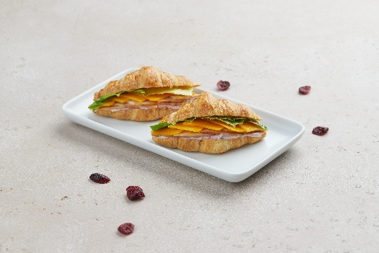

***Turkey Swiss Cheese Mini Plain Croissant***

|  |  |  |
| --- | --- | --- |
| ***Creamy Cranberry Mix*** | | |
| **Item Name** | **Quantity (g)** | **Calories** |
| Cream Cheese | 100 g | 200 Cal |
| Light Mayonnaise | 30 g | 70 Cal |
| Cranberry Sauce | 25 g | 40 Cal |
| ***Total*** | 155 g | 310 Cal |
| ***2.00 Cal/g*** | |

|  |  |  |  |
| --- | --- | --- | --- |
| **Item Name** | **1p** | **2p** | **3p** |
| Mini Croissant | 40g / 115 Cal | 60g / 173 Cal | 60g / 173 Cal |
| Creamy Cranberry Mix | 20g / 40 Cal | 30g / 60 Cal | 50 g / 100 Cal |
| Cheddar Cheese | 10g / 35 Cal | 15g / 60 Cal | 20g / 70 Cal |
| Turkey | 20 g / 20 Cal. | 30 g / 30 Cal. | 50 g / 50 Cal |
| Iceberg Lettuce | 15 g / 2 Cal. | 15 g / 2 Cal. | 15 g / 2 Cal. |
| ***TOTAL*** | 105g/212 Cal | 150g/325 Cal | 195g/395 Cal |

***Feta Pie Recipe:***

|  |  |  |
| --- | --- | --- |
| **Item Name** | **Quantity** | **Calorie** |
| ***Feta Cheese Mix:*** | | |
| Feta Cheese | 1 kg | 2500 Cal |
| Fresh Tomato | 900 g | 162 Cal |
| Onion | 150 g | 60 Cal |
| Oregano | 5 g | 5 Cal |
| Olive Oil | 50 g | 450 Cal |
| ***Total*** | ***2,105 g*** | ***3177 Cal***  ***1.5 Cal/g*** |

|  |  |  |
| --- | --- | --- |
| **Item Name** | **Quantity** | **Calorie** |
| ***White Dough:*** | | |
| White Flour | 1 kg | 3,640 Cal. |
| Light Butter | 50 g | 358 Cal. |
| White Sugar (Maltitol) | 40 g | 80 Cal. |
| Powder Milk | 50 g | 250 Cal. |
| Salt | 15 g | 0 Cal. |
| Yeast | 15 g | 15 Cal. |
| Water | 700 ml | 0 Cal. |
| Flaxseed | 2 g | 0 Cal. |
| ***Total*** | ***1,872 g*** | ***4,343 Cal.*** |
|  | ***30 g*** | ***70 Cal.*** |

|  |  |  |  |
| --- | --- | --- | --- |
| **Item Name** | **1P** | **2P** | **3P** |
| White Dough | 50 g / 117 Cal | 70 g / 163 Cal | 100 g / 233 Cal |
| Feta Cheese Mix. | 35 g / 52 Cal | 50 g / 75 Cal | 70 g / 105 Cal |
| Black & White Sesame Seeds (Garnish on top) | 1 g / 6 Cal | 1 g / 6 Cal | 2 g / 12 Cal |
| Rocca | 10 g / 2 Cal | 10 g / 2 Cal | 10 g / 2 Cal |
| Cherry Tomato | 30 g / 5 Cal | 30 g / 5 Cal | 30 g / 5 Cal |
| Black Olives | 5 g / 6 cal | 10 g / 11 Cal | 15 g / 17 Cal |
| ***Total*** | ***131 g/ after cook will be 104 g = 190 Cal.*** | ***171 g / after cook will be 137 g = 270 Cal.*** | ***227 g/ after cook will be 182 g = 380 Cal.*** |

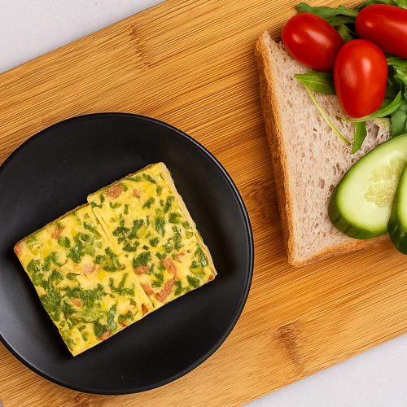

***Spanish Omelet New:***

|  |  |  |
| --- | --- | --- |
| **Item Name** | **Quantity** | **Calorie** |
| ***Egg Omelet Mix:*** | | |
| Whole Egg | 500 g | 750 Cal. |
| Spring Onion | 25 g | 10 Cal |
| Tomato | 125 g | 25 Cal |
| Green Pepper | 25 g | 9 Cal |
| White Pepper | 5 g | 15 Cal |
| Parsley | 25 g | 5 Cal |
| Salt | 10 g | 0 Cal |
| Cooking Cream | 75 g | 270 Cal |
| ***Total*** | ***790 g before cook,***  ***630 g after cook.*** | ***1,085 Cal.*** |
| ***Egg Omelet Mix*** | ***1.3 Cal./g.*** | |

|  |  |  |  |
| --- | --- | --- | --- |
| **Item Name** | **1P** | **2P** | **3P** |
| Egg Omelet | 90 g / 117 Cal | 120 g / 156 Cal | 150 g / 195 Cal |
| Rocket | 10 g / 2 Cal | 10 g / 2 Cal | 10 g / 2 Cal |
| Cherry Tomato | 30 g / 5 Cal | 30 g / 5 Cal | 30 g / 5 Cal |
| Cucumbers | 20 g / 4 Cal | 20 g / 4 Cal | 20 g / 4 Cal |
| Bread | 30g / 80 Cal | 45g / 120 Cal | 60g / 160 Cal |
| ***Total*** | ***150 g / 208 Cal*** | ***180 g / 287 Cal*** | ***210 g / 366 Cal*** |

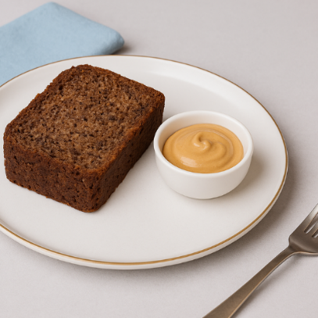

***Banana Bread with Peanut Butter Recipe:***

|  |  |  |
| --- | --- | --- |
| **Item Name** | **Quantity** | **Calorie** |
| ***Banana Bread:*** | | |
| Eggs | 112 g | 160 Cal. |
| Maltitol Sugar | 112 g | 269 Cal. |
| Canola Oil | 90 ml | 810 Cal. |
| White Flour | 112 g | 400 Cal. |
| Baking Soda | 3 g | 0 Cal |
| Baking Powder | 3 g | 11 Cal |
| Banana | 112 g | 100 Cal. |
| Vanilla Essence | 5 g | 20 Cal. |
|  | 549 g  494g after cooking | 1770 Cal  3.6 Cal/g |
| ***Homemade Peanut Butter:*** | | |
| Roasted Peanuts | 700 g | 3970 Cal |
| Erythritol | 20 g | 0 cal |
| Salt | 5 g | 0 Cal |
|  | 725g | 3970 Cal  5.5 Cal/g |

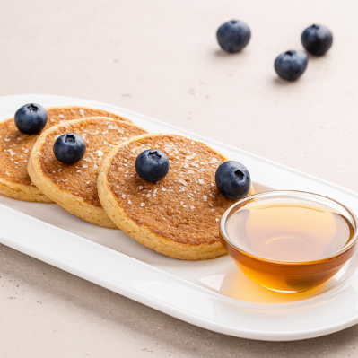

***Dates Oat Pancakes with Honey***

|  |  |  |
| --- | --- | --- |
| *Date Pancake Mix* | | |
| **Item Name** | **Quantity (g)** | **Calories** |
| Oats | 180 g | 675 Cal |
| Water | 300 g | 0 Cal |
| Eggs | 130 g | 160 Cal |
| Milk Powder | 50 g | 170 Cal |
| Coconut Oil | 15 g | 130 Cal |
| Date Paste | 100 g | 310 Cal |
| Baking Powder | 10 g | 10 Cal |
| Baking Soda | 5 g | 10 Cal |
| Cinnamon | 5 g | 5 Cal |
| Salt | 2 g | 0 Cal |
| ***Total*** | 797 g | 1470 Cal |
| ***1.84 Cal/g*** | |

Note: 35g Before cook, then 25g after cook

|  |  |  |  |
| --- | --- | --- | --- |
| **Item Name** | **1p** | **2p** | **3p** |
| Oat Pancake | 2 pcs / 130 Cal | 3 pcs / 190 Cal | 4 pcs / 260 Cal |
| Honey | 25 g / 83 Cal | 25 g / 83 Cal | 25 g / 83 Cal |
| Blueberries | 20 g/ 10 Cal | 20 g/ 10 Cal | 20 g/ 10 Cal |
| ***TOTAL*** | 95g / 223 Cal | 120g / 283 Cal | 145 g/ 353 Cal |

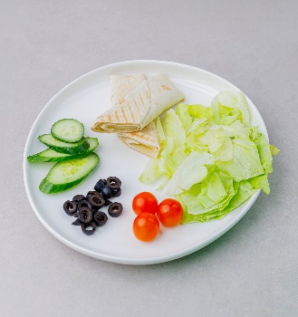

***Kashkaval Cheese & Thyme with Whole Wheat Tortilla***

|  |  |  |
| --- | --- | --- |
| ***Zaatar Mix.*** | | |
| Zaatar | 600 g |  |
| AOlive Oil | 300 g |  |
| Water | 600 g |  |
| Salt | 5g |  |
| ***Total*** | ***1.7 Cal. / g*** |  |

|  |  |  |  |
| --- | --- | --- | --- |
| **Item Name** | **1P** | **2P** | **3P** |
| Tortilla Bread | 30 g / 80 Cal. | 60 g / 150 Cal. | 60 g / 150 Cal. |
| Zaatar Mix | 20 g / 34 Cal. | 20 g / 34 Cal. | 20 g / 34 Cal. |
| Kashkaval Cheese | 40 g / 100 Cal. | 60 g / 150 Cal. | 80 g / 200 Cal. |
| Iceberg Lettuce | 20 g / 3 Cal. | 30 g / 4 Cal. | 30 g / 4 Cal. |
| Cucumber | 30 g / 4 Cal. | 40 g / 5 Cal. | 40 g / 5 Cal. |
| Cherry Tomato | 30 g / 6 Cal. | 30 g / 6 Cal. | 30 g / 6 Cal. |
| Black Olives | 5 g / 6 Cal. | 5 g / 6 Cal. | 10 g / 12 Cal. |
| ***Total*** | ***155 g / 199 Cal.*** | ***225 g / 321 Cal.*** | ***250 g / 377 Cal.*** |

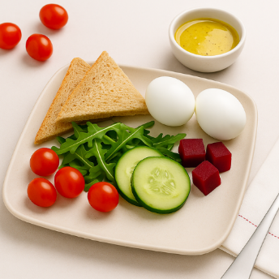

***Boiled Eggs with Arugula and Beetroot***

|  |  |  |  |
| --- | --- | --- | --- |
| **Item Name** | **1P** | **2P** | **3P** |
| Boiled Eggs | 2 eggs = 100 g / 150 Cal. | 3 eggs = 150 g / 225 Cal. | 4 eggs = 200 g / 300 Cal. |
| Rocca | 30 g / 8 Cal. | 50 g / 13 Cal. | 70 g / 18 Cal. |
| Cooked Beetroot | 80 g / 35 Cal. | 100 g / 44 Cal. | 120 g / 53 Cal. |
| Lemon Mustard Dressing | 15g / 34 Cal | 15g / 34 Cal | 15g / 34 Cal |
| ***Total*** | ***225g = 227 Cal*** | ***315g = 316 Cal*** | ***405g = 405 Cal*** |

|  |  |  |
| --- | --- | --- |
| **Item Name** | **Quantity** | **Calorie** |
| **Honey Lemon Mustard Dressing: for 1 KG** | | |
| Olive Oil | 20g | 180 Cal |
| Mustard | 25 g | 20 Cal |
| Honey | 30 g | 91 Cal |
| Lemon Juice | 30 g | 6.6 Cal |
| Salt | 3 g | 0 Cal |
| Apple Cider Vinegar | 25 g | 6 cal |
| White Pepper | 2 g | 0 Cal |
|  | 135 g | 303 Cal  2.24 Cal/g |

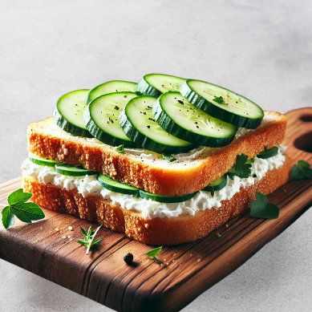

***Cream Cheese Sandwich***

|  |  |  |
| --- | --- | --- |
| ***Cream Cheese and Cucumber Mix*** | | |
| **Item Name** | **Quantity (g)** | **Calories** |
| Cream Cheese | 60 g | 210 Cal |
| Low Fat Plain Greek Yogurt | 15 g | 10 Cal |
| Sliced Fresh Chives | 1 g | 5 Cal |
| Chopped Fresh Dill | 1 g | 0 Cal |
| Ground Pepper | 1 g | 0 Cal |
| Cucumber (Thinly Sliced) | 60 g | 5 Cal |
| ***Total*** | 138 g | 230 Cal |
| ***1.67 Cal/g*** | |

|  |  |  |  |
| --- | --- | --- | --- |
| **Item Name** | **1P** | **2P** | **3P** |
| Toast Bread | 30g / 75 Cal. | 60g / 150 Cal. | 75g / 200 Cal. |
| Cheese & Cucumber Mix | 60 g / 100 Cal. | 80 g / 134 Cal. | 100 g / 167 Cal. |
| Rocca | 10 g / 6 Cal. | 10 g / 6 Cal. | 20 g / 12 Cal. |
| Cherry Tomato | 30 g / 5 Cal. | 30 g / 5 Cal. | 30 g / 5 Cal. |
| ***Total*** | ***130g/186 Cal.*** | ***180/295 Cal*** | ***225g/384Cal*** |

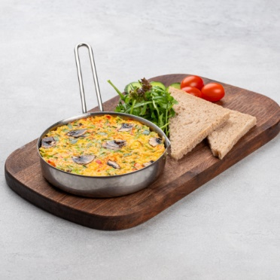

***Vegetable & Mushroom Omelet Recipe:***

|  |  |  |
| --- | --- | --- |
| **Item Name** | **Quantity** | **Calorie** |
| ***Egg Omelet Mix:*** | | |
| Whole Egg | 500 g | 750 Cal. |
| Spring Onion | 25 g | 10 Cal |
| Chopped Tomato | 125 g | 25 Cal |
| Chopped Mushroom | 25 g | 10 Cal |
| Green Pepper | 25 g | 9 Cal |
| White Pepper | 5 g | 15 Cal |
| Parsley | 25 g | 5 Cal |
| Salt | 10 g | 0 Cal |
| Cooking Cream | 75 g | 270 Cal |
| ***Total*** | ***840 g before cooking,***  ***640 g after cooking.*** | ***1,095 Cal.*** |
| ***Egg Omelet Mix*** | ***1.3 Cal./g.*** | |

|  |  |  |  |
| --- | --- | --- | --- |
| **Item Name** | **1P** | **2P** | **3P** |
| Egg Omelet | 90 g / 117 Cal | 120 g / 156 Cal | 150 g / 195 Cal |
| Rocket | 10 g / 2 Cal | 10 g / 2 Cal | 10 g / 2 Cal |
| Cherry Tomato | 30 g / 5 Cal | 30 g / 5 Cal | 30 g / 5 Cal |
| Cucumbers | 20 g / 4 Cal | 20 g / 4 Cal | 20 g / 4 Cal |
| Toast Bread (Brown) | 30g / 80 Cal | 45g / 120 Cal | 60g / 160 Cal |
| ***Total*** | ***150 g / 208 Cal*** | ***180 g / 287 Cal*** | ***210 g / 366 Cal*** |

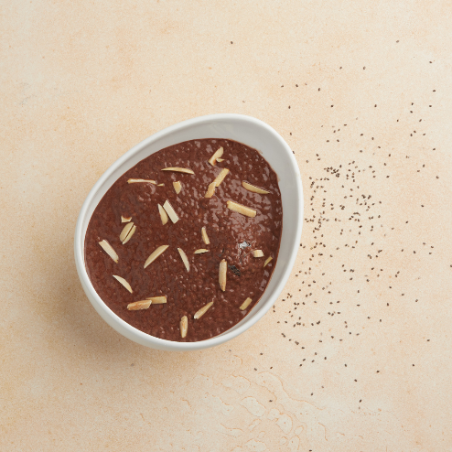

***Chocolate Chia Pudding***

|  |  |  |
| --- | --- | --- |
| *Chocolate Chia Mix* | | |
| **Item Name** | **Quantity (g)** | **Calories** |
| Low Fat Milk | 250 g | 100 Cal |
| Date Paste | 50 g | 160 Cal |
| Cocoa Powder | 10 g | 25 Cal |
| Chia Seeds | 5 g | 25 Cal |
| ***Total*** | 315 g | 310 Cal |
| ***0.98 Cal/g*** | |

|  |  |  |  |
| --- | --- | --- | --- |
| **Portions** | **1P** | **2P** | **3P** |
| Chia Pudding mix | 150g / 147 Cal | 200g / 196 Cal | 250g / 240 Cal |
| Almond Nibs | 5g/ 30 Cal | 10g/ 60 Cal | 10 g/ 60 Cal |
| ***Total*** | ***155g/177 Cal*** | ***210g/256 Cal*** | ***255g/300 Cal*** |

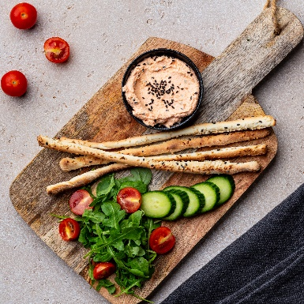

***Labneh with Thyme and Red Pepper with and Grassini Sticks***

|  |  |  |
| --- | --- | --- |
| ***Labneh Mixture*** | | |
| Labneh | 500 g | 1000 Cal |
| Sweet Pepper Paste | 35 g | 11 Cal |
| Fresh Thyme | 5 g | 5 Cal |
| Tabasco | 3g | 9 Cal |
| ***Total*** | ***543 g*** | 1025 Cal  1.9 Cal/g |

|  |  |  |
| --- | --- | --- |
| ***Pizza Dough*** | | |
| **Item Name** | **Quantity (g)** | **Calories** |
| White Flour | 1000 g | 3600 Cal |
| Egg | 60 g | 75 Cal |
| Sugar (Maltitol) | 30 g | 66 Cal |
| Low Fat Butter | 100 g | 500 Cal |
| Milk Powder | 50 g | 179 Cal |
| Water | 580 g | 0 Cal |
| Yeast | 15 g | 15 Cal |
| ***Total*** | 1835 g before cook | 4435 Cal |
| 1688 g after cook |
| ***2.6 Cal/g*** | |

|  |  |  |  |
| --- | --- | --- | --- |
| **Portion** | **1P** | **2P** | **3P** |
| Grassini Sticks | 30g / 78 Cal | 45g / 117 Cal | 60g / 156 Cal |
| Labneh Mixture | 50g / 95 Cal | 70g / 133 Cal | 90g / 171 Cal |
| Rocket | 10 g / 2 Cal | 10 g / 2 Cal | 10 g / 2 Cal |
| Cherry Tomato | 30 g / 5 Cal | 30 g / 5 Cal | 30 g / 5 Cal |
| Cucumbers | 20 g / 4 Cal | 20 g / 4 Cal | 20 g / 4 Cal |
| Black Seeds | Garnish | Garnish | Garnish |
| ***Total*** | ***184 Cal*** | ***261 Cal*** | ***338 Cal*** |

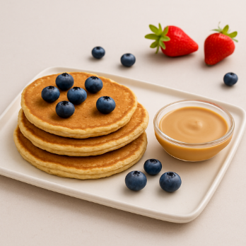

***Protein Pancake Recipe:***

|  |  |  |
| --- | --- | --- |
| **Item Name** | **Quantity** | **Calorie** |
| ***Protein Pancake:*** | | |
| Whey Protein Powder | 90 g | 339 Cal. |
| Oats | 180 g | 200 Cal. |
| Eggs | 3 pcs | 225 Cal. |
| Milk | 300 g | 150 Cal. |
| Baking Powder | 15 g | 9 Cal. |
| Cinnamon | 3 g | 1 Cal. |
| ***Total*** | ***813 g*** | ***924 Cal.*** |

***NOTE: Each Piece 28 g before cooking, after cooking = 20 g. (50 Cal.)***

|  |  |  |
| --- | --- | --- |
| ***Peanut Butter and milk :*** | | |
| Peanut butter | 15 g | 100 Cal. |
| Milk low fat | 15 g | 8 Cal. |
| ***Total*** | ***30 g*** | ***108Cal.*** |

|  |  |  |  |
| --- | --- | --- | --- |
| **Item Name** | **1p** | **2p** | **3p** |
| Protein Pancake | 2 pcs (40 g) / 100 Cal. | 3 pcs (60 g) / 150 Cal. | 4 pcs (80 g) / 200 Cal. |
| Peanut Butter + Milk | 30 g / 108 Cal | 45 g / 162 Cal | 60 g / 216 Cal |
| Mix Berries | 2 pc strawberry + 5 pcs blueberries | 2 pc strawberry + 5 pcs blueberries | 2 pc strawberry + 5 pcs blueberries |
| ***Total*** | 215 Cal | 320 cal | 420 Cal |

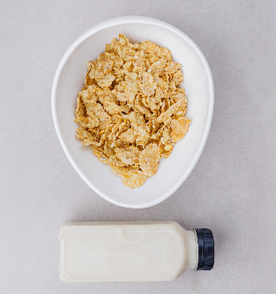

***Cereals & Almond Milk Recipe:***

|  |  |  |  |
| --- | --- | --- | --- |
| **Item Name** | **1p** | **2p** | **3p** |
| Cereals (any flavors) | 40 g/140 Cal | 50 g/180 Cal | 80 g/280 Cal |
| Unsweetened Almond Milk | 100 ml/15 Cal | 200 ml/ 30 Cal | 200 ml/30 Cal |
| ***TOTAL*** | ***140 g/155 Cal*** | ***250 g/210 Cal*** | ***280 g/310 Cal*** |

***Cocktail Mankushe Recipe:***

|  |  |  |
| --- | --- | --- |
| **Item Name** | **Quantity** | **Calorie** |
| White Flour | 1 kg | 3,640 Cal. |
| Light Butter | 50 g | 258 Cal. |
| Maltitol | 40 g | 96 Cal. |
| Powder Milk | 50 g | 250 Cal. |
| Salt | 15 g | 0 Cal. |
| Yeast | 15 g | 15 Cal. |
| Water | 700 ml | 0 Cal. |
| Flaxseed | 2 g | 0 Cal. |
| ***Total*** | ***1,872 g*** | ***4259 Cal.***  ***2.3 Cal/g*** |
| **Item Name** | **Quantity** | **Calorie** |
| ***Zaatar Mix.*** | | |
| Zaatar | 1200 g | 4800 Cal |
| Olive Oil | 600 g | 5300 Cal |
| Water | 1500 g | 0 Cal |
| Salt | 12 g | 0 Cal |
| ***Total*** | 3312 g | 10100 |
| ***Cal/g*** | ***3.0 Cal. / g*** | |
|  |

|  |  |  |
| --- | --- | --- |
| **Item Name** | **Quantity** | **Calorie** |
| ***Cheese Mix.*** | | |
| Mozzarella Cheese | 200 g | 316 Cal. |
| Halloumi Cheese | 100 g | 220 Cal. |
| ***Total*** | ***300 g*** | ***536 Cal.*** |
| ***Cheese Mix.*** | ***30 g*** | ***80 Cal.*** |

|  |  |  |  |
| --- | --- | --- | --- |
| **Item Name** | **1p** | **2p** | **3p** |
| White Dough | 60 g / 140 Cal. | 80 g /185 Cal. | 100 g / 231 Cal. |
| Zaatar Mix | 15 g / 45 Cal. | 25 g / 75 Cal. | 35 g / 105 Cal. |
| Cheese Mix | 15 g / 43 Cal. | 25 g / 66.5 Cal. | 35 g / 93 Cal. |
| ***TOTAL*** | **90 g / 228 Cal.** | **130 g / 326 Cal.** | **170 g / 429 Cal.** |

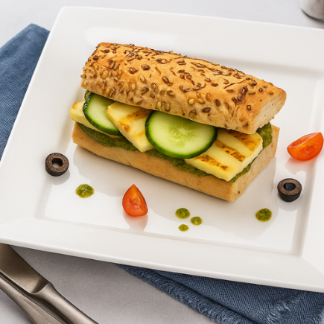

***Halloumi Sandwich Recipe:***

|  |  |  |  |
| --- | --- | --- | --- |
| **Item Name** | **1P** | **2P** | **3P** |
| Baguette Bread | 30 g / 80 Cal. | 60 g / 160 Cal. | 60 g / 160 Cal. |
| Halloumi Cheese | 40 g / 100 Cal. | 60 g / 150 Cal. | 80 g / 200 Cal. |
| Cherry Tomato | 30 g / 6 Cal. | 30 g / 6 Cal. | 40 g / 8 Cal. |
| Cucumber | 30 g / 5 Cal. | 30 g / 5 Cal. | 40 g / 8 Cal. |
| Black Olives | 10 g / 12 Cal. | 10 g / 12 Cal. | 15 g / 18 Cal. |
| ***Total*** | ***140 g / 203 Cal.*** | ***190 g / 333 Cal.*** | ***235 g / 394 Cal.*** |

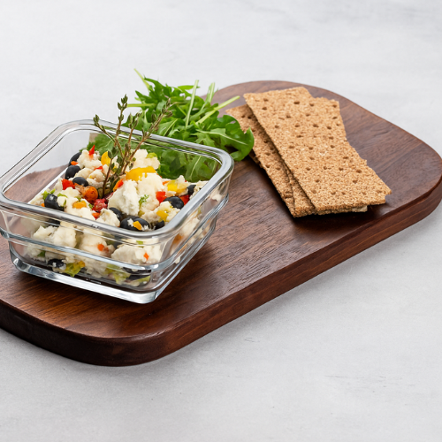

***Feta Cheese with Rye Crisps***

|  |  |  |
| --- | --- | --- |
| **Item Name** | **Quantity** | **Calorie** |
| ***Cheese Veg. Mix.*** | | |
| Feta Cheese | 500 g | 1,250 Cal. |
| Mix Bell Pepper | 100 g | 30 Cal. |
| Olive Oil | 15 g | 135 Cal. |
| Fresh Thyme | 5 g | 5 Cal. |
| Black Olives | 20 g | 25 Cal. |
| ***Total*** | ***645 g*** | ***1,447 Cal.*** |
| ***Cheese MIX*** | ***2.24 Cal./g.*** | |

|  |  |  |  |
| --- | --- | --- | --- |
| **Item Name** | **1P** | **2P** | **3P** |
| Rye Crisps | 2 pieces / 70 Cal. | 3 pieces / 105 Cal. | 4 pieces / 140 Cal. |
| Rocca | 10 g / 6 Cal. | 10 g / 6 Cal. | 20 g / 12 Cal. |
| Cheese Mix | 60 g / 134 Cal. | 80 g / 179 Cal. | 100 g / 224 Cal. |
| ***Total*** | ***100g = 210 Cal*** | ***135g = 290 Cal*** | ***180g = 376 Cal*** |